The United Methodist Church

Attica – Pershing, Zion
South Attica St.
Knoxville Iowa 50138
(641-943-2324)
October, November, December 2025

The Living Word of God

Have you ever noticed how you can read scripture once and hear one message, but when you come back to those same verses a few days, weeks, or even years down the road the message you hear changes? Why is that? The words themselves haven’t changed, but what you take from them can be vastly different. This is because the Bible is the Living Word of God. The Bible is more than just words on a page, it is words written by human beings over the millennia but inspired by God, and when we read them, we are inspired by the Holy Spirit within us. It is that Spirit that changes how we receive the Word and apply it to our lives today.
We know that even the most recently written book of the bible is still nearly 2,000 years old. How can something written that long ago even remotely apply to our life today, let alone the stories from the beginning of time in Genesis? It is by the power of the Spirit and the grace of God that we can apply these ancient words, written at a different time, to a different people, in a different culture and context, to our lives in the twenty-first century.
The Word of God is truth and the message it speaks can be different for each of us. Each of us reads the Bible through the context of our own life experiences, and also through the lens of our knowledge of the Biblical context, when it was written, who it was written for, etc. These lenses, along with the Holy Spirit, alter the message we receive through our reading. The Bible is not black and white, some might call it grey, but I like to think of it as a kaleidoscope, vibrant and living, moving through time and space, across places, people, and cultures. It is God’s truth that reaches us in all times and places.
If you have ever wondered about how to get more out of reading scripture, try a practice called Lectio Divine – divine reading. This process invites God to join you in your reading, opening your mind and soul to hear the message God has for you that day. It allows you to go deeper than just reading the Bible as a history book or rule book. Lectio Divina lets you dive into this Living Word, experiencing it on a multitude of levels, and really focusing on what God is trying to tell you through these ancient texts. Here are a few simple steps to Lectio Divina.

- Prepare – give yourself time, at least 10 minutes to devote to your reading. Pick a place that is quiet, peaceful, and relaxing to you, free of distractions.
- Pick your scripture – you can use the lectionary, a scripture that fits your mood/circumstance, or just randomly select one. Try to keep the passage short, under 10 verses. You can also use other material such as devotionals and religious poetry for Lectio Divina.
- Begin by praying – asking God to join you in your reading and reveal God’s message to you.
- Read the scripture slowly – aloud or silently, pausing between phrases and sentences. Read the passage more than once. Let the words echo and resonate in your mind. Allow meanings to sink in, images to surface, associations to arise. If a word or phrase sticks out, sit with it for a while.
- Reflect on a word or phrase. Let the special word or phrase that you discovered in sink into your heart. Ask questions like ‘why is this word/phrase meant for you? What is God telling you? What in your life needs to hear this word?’
- Respond to what you have read. Form a prayer that expresses your response to the idea, then “pray it back to God.” What you have read is woven through what you tell God.
- Rest in God’s word. Let the text soak into your deepest being, savoring an encounter with God and truth. Let it be an invitation to turn to a place of rest near to the heart of God where you are at peace. When ready, move toward the moment in which you ask God to show you how to live out what you have experienced.
Happy Reading!

Blessings,
Pastor Lauren Petersen

*******************************************************************************************************************

UNITED WOMEN OF FAITH

Attica United Women of Faith – The Attica United Women of Faith met September 4, 2025. Present were, Lou Ann, Marlys, Bobbi, Debbie, Sue and Frances. Minutes were read and treasurers report given. Lou Ann discussed some newsletters. The soup supper as tentatively set for March 19, 2026. Lou Ann gave the lesson, “Choose Prayer Power.” How Shall We Pray? (1) Pray affirmatively (2) Pray words of praise to our Father (3) Pray expecting blessings – even if small (4) Pray with humility – seek forgiveness (5) Pray for protection (6) Give God the glory.

Zion United Women of Faith - The Zion UWF held their meeting on September 3 at the church. Present were Sue Pelong, Leanna Kennedy, Jo Heigele, Wanita Banks, Jan Mortenson, Jodi Swayne, Pat Blom & Cindy Pettyjohn. The meeting was called to order by Leanna. Wanita had the program entitled "What is faithfulness to you?". The Bible verse for this month was Micah 6:8 which is also our church motto: "He has shown you, O mortal, what is good. And what does the Lord require of you? To act justly, and to love mercy and to walk humbly with your God"
We discussed plans for our upcoming Fellowship Day on October 11, 2025 at noon. We also mentioned plans for our upcoming Thanksgiving dinner which is held after church on
November 23.
The meeting closed with the reading of the Purpose. Refreshments were served by Jo. Our next meeting will be held on Thursday, Oct. 2nd. at 11 A.M.

*******************************************************************************************************************
RECAP OF PARISH EVENTS

For Father’s Day Zion decided to give the dads a Snickers candy bar with a note that said "Being a Fantastic Dad is nothing to snicker about".

On Sunday, July 6th Zion hosted the Blue Grass Blondies, a family from Ottumwa that sing gospel music. We have had them previously and always enjoy hearing them.

On July 17 we held our annual State Fair Coffeetime. Our first competition was horseshoe pitching with used horseshoes (not the regulation heavy kind). We all got 4 times to throw the horseshoes. The winner was Tina Maddison with 2 ringers and Linda Kizer was 2nd with 1. Next we had a bubble gum blowing contest to see who was able to get the biggest bubble. Of course those with dentures couldn't participate. We had several doing a good job and close competition between Jody Swayne and Sue Mallory with Sue winning. Our 3rd game was our version of carving with butter. As we weren't working in a freezer we had to limit our time handling a stick of butter to carve out something(?) in 15-20 minutes. We had some interesting ideas including an ear of corn, snowmen, tree, and a bowling ball with 3 holes for the fingers. Our judge was Rick Mortenson who chose Tina Maddison's deluxe snowman! Afterwards our refreshments were corndogs, lemonade and popcorn.

On August 17, our speaker was Kodis Rawlings. He continued Pastor Lauren's series on the Parables.

On August 24 Attica held their annual Ice Cream Social. There was plenty of ice cream and desserts for all. This year the Loynachans Gospel singing family performed before the ice cream social. As always they were wonderful.

*****************************************************************************************************************
PARISH UPCOMING EVENTS

October 8 - There will be a Worship Committee meeting at 2 pm following Bible Study.

October 11 - Mark your calendars for Zion United Women of Faith’s Fellowship Day at noon.

November 23 – Zion Ad Council meeting – following service

November 11 – Attica Ad Council meeting – 1:00 pm

November 23 – Thanksgiving Potluck at Zion – following service

January 4, 2026 – Our Sunday service time will change to 10:30 am.

******************************************************************************************************************************

REACHING OUT TO OUR SHUT-INS - It was decided to add a list of our shut-ins to each Challenger if you would like to reach out to someone. A friendly note or a visit is always welcomed.

Connie Baily, 2092 Hwy 156, Bussey, IA 50044
Harry Hart, Westridge Reb & Care Nursing Home, 904 W. Howard, Knoxville IA 50138
Rachel Hoehns,1557 Hwy G76, Knoxville, IA 50138
Marilyn Rice, West Ridge Specialty Care, 711 Willetts Dr. Knoxville, IA 50138
Bertha Gibbons, West Ridge Specialty Care, 711 Willetts Dr., Knoxville, IA 50138
Germaine Whitlatch, 1523 Hwy G76, Knoxville, IA 50138
Patty Fudge, 2042 Orange St., Knoxville, IA 50138
Carol Bruce, 1805 178th Place, Knoxville, IA 50138
Eloise Snow, West Ridge & Care Nursing Home, 904 W. Howard, Knoxville, IA 50138
Dick Rowland, 705 E. Robinson, Knoxville, IA 50138
Ruth Little, Homestead Assisted Living 908 S. Park Ln Dr., Knoxville, IA 50138
Vickie Rumley, 1826 178thy Place, Knoxville, IA 50138
******************************************************************************************************************************

SCHEDULE OF SUNDAY SERVICE AND LEADERS FOR OCTOBER NOVEMBER AND DECEMBER: (All services will be held at 10:00 am) There will be fellowship/coffee time from 9:30-10:00 at Attica only.

OCTOBER NOVEMBER
Oct. 5 – Lou Ann Willis @ Attica - Communion Nov. 2 – Bobbi Bassett @ Attica - Communion
Oct. 12 – Linda Kizer @ Zion Nov. 9 – Linda Kizer @ Zion
Oct. 19 – Debbie Phipps @ Attica Nov. 16 – Tim DeGeest @ Attica
Oct. 26 – Jan or Leanna@ Zion Nov. 23 – Leanna Kennedy @ Zion
Nov. 30 – Marlys Hollingshead @ Attica

DECEMBER
Dec. 7 – Linda Kizer @ Zion, Communion
Dec. 14 – Lou Ann Willis @ Attica
Dec. 21 – Jan Mortenson @ Zion
Dec. 28 – Debbie Phipps @ Attica

******************************************************************************************************************************
ATTENDANCE

ATTICA: July: 6-11, 13-10, 20-16, 27-13, August: 10-14, 17-9, 24-14, 31-12,
September: 7-15, 14-16, 21-12

ZION: July: 6-11, 13-7, 20-8, 277, August: 10-5, 17-14, 24-9, 31-8,
September: 7-7, 14-9, 21-5

******************************************************************************************************************************

Prayer Concerns (including families)

Carole Bruce Sue Pelong Charlene Stevens
Germaine Whitlatch Rachel Hoehns Heather Brown
Pastor Bud Lane Bertha Gibbons Vickie Rumley
Wanita Banks Mary Pinegar Casey Ryan
Connie Bailey Linda Kizer Eloise Snow
Mary Clifford Dwain Kennedy Arleen Ensor
Jim Pelong Harry Hart

October 2025
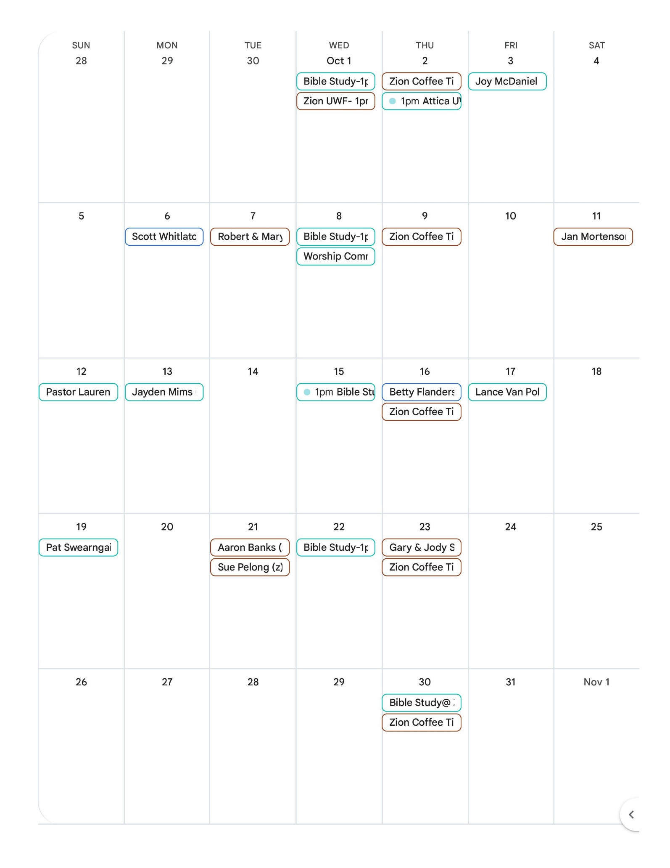
November, 2025

December, 2025
